Using a pad
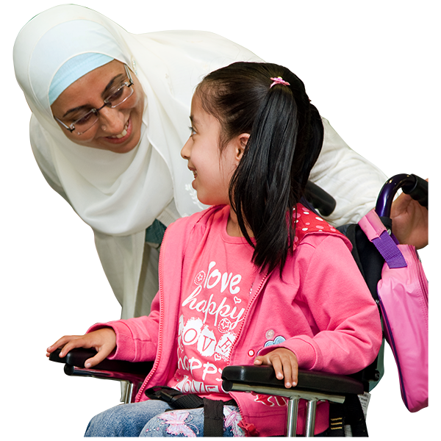
Lots of people choose to use pads when they have their period.
Some parents might be worried about teaching their child to use a pad.
You might be worried that your child will:
- dislike how a pad feels in their underwear
- find it hard to learn how to use a pad correctly
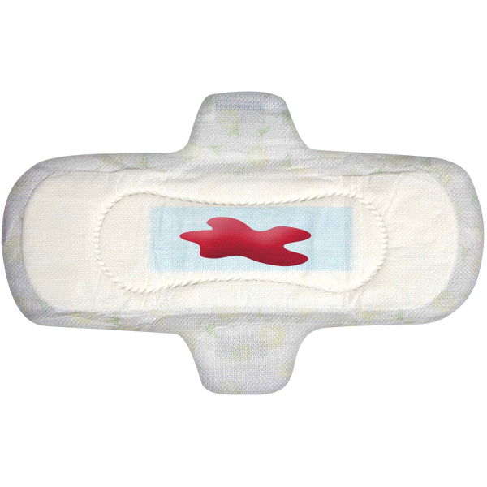
- not be able to change their pad by themselves
- need help to change their pad at school
Lots of parents worry about this. It is OK.
Some girls can learn to use pads by themselves. Some girls can learn to use pads with help from other people.
To help your child learn to use a pad it is important to:
- talk to your child about periods and pads
- educate your child about periods and pads
- practice using pads before your child starts their period

What is on this page?
This page is about how you can teach your child to use a pad when they have their period.
It has information on:
- preparing your child for their period
- how to teach your child to use a pad
- privacy
- other period product options

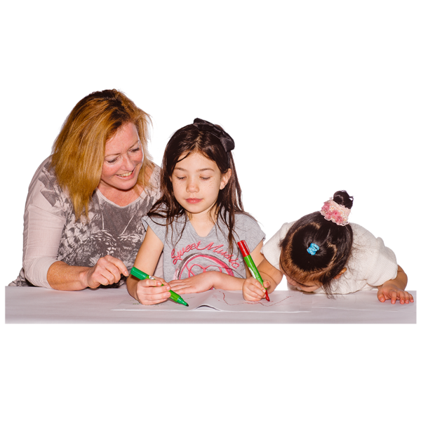
Preparing your child for their period
It is important to give your child lots of time to learn about periods.
You should try to talk to your child about periods before their period starts.
This will help them to be better prepared when their period starts.
You can get more information on how to talk to your child about periods here Talking About Periods
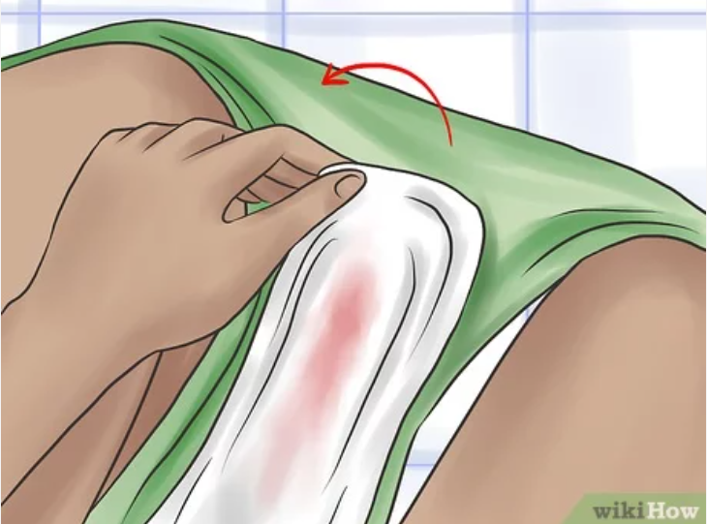
Your child can practice wearing a pad before their period starts. This can help them to understand:
- what a pad feels like
- how to put a pad on underwear
- how to take off a used pad
Here are some ways to prepare your child.
Practicing with dolls
- Pick a doll that wears clothes and underwear
- Buy some panty liners
- Cut panty liners to fit the size of the doll’s underwear
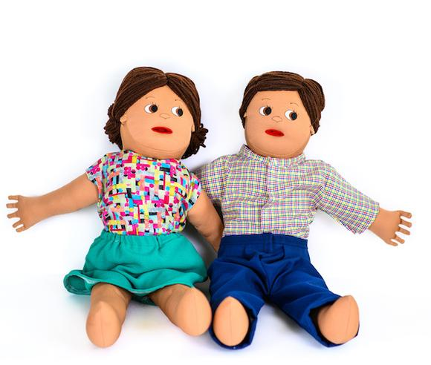
- Help your child to peel the plastic off the back of the panty liner
- Put the sticky side of the panty liner on the doll’s underwear
- When your child is not looking use a red marker to colour the panty liner
- Tell your child they will need to check the doll’s underwear every day. If there is red on the doll’s pad it means they will have to change the pad
- Help your child to practice rolling up the old pad and putting it in the bin
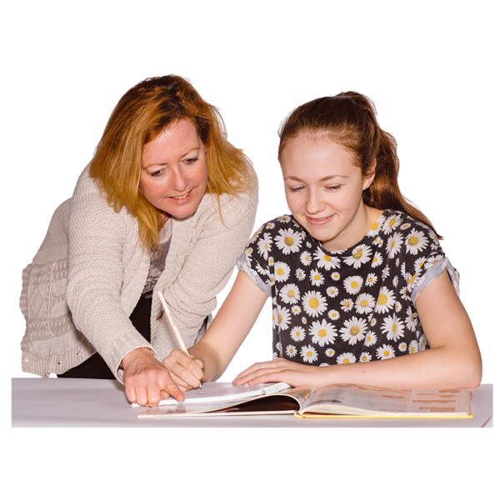
Modelling
- If you get a period it can be helpful to show your child your period blood.
- You can also show them how you use a pad. This is called modelling.
- Tell them this is a normal part of being a woman.
- Tell them that they will have a period when they grow up.
- Show them how you take off a used pad and how to put on a new one.
Teaching your child to use a pad
Some children will be able to change their pad by themselves. Some children will need some help. This is OK.
You can try different things to help your child to learn to change their pad.
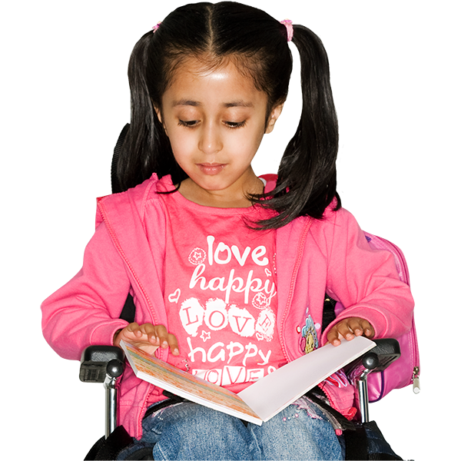
Stories and pictures
Use stories and pictures to remind your child to change their pad.
There are some examples of social stories and pictures for changing a pad in the list at the bottom of this page.
You can put these pictures on the back of the toilet door at home. You can also put a copy in your child’s school bag.
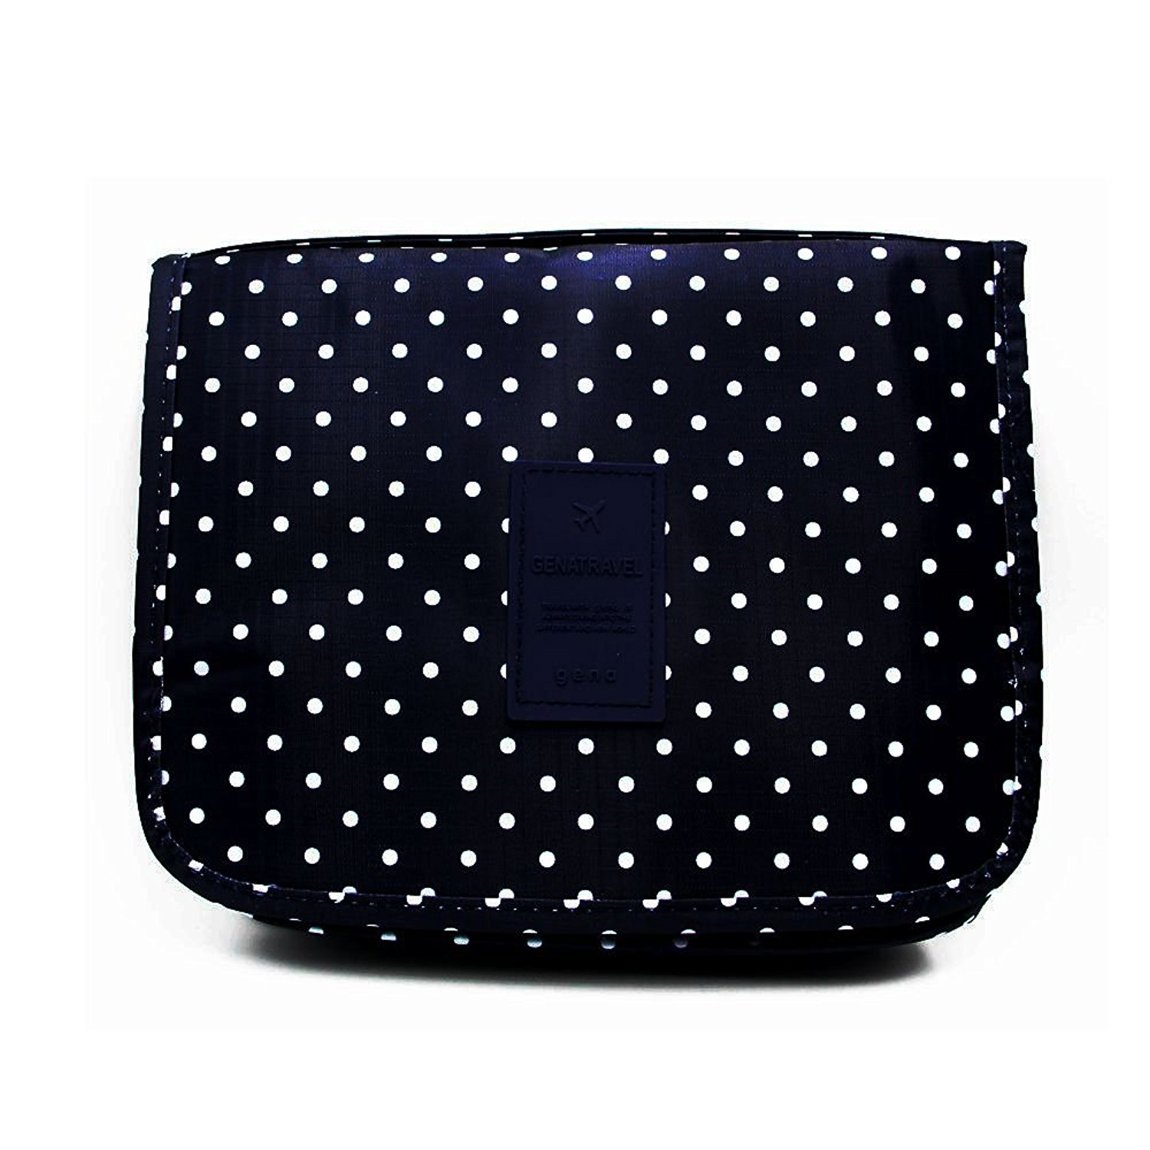
Period kits
Let your child choose a fun bag or case to hold their special period things. This is called a period kit.
You can put these things in the period kit:
- pads
- a spare pair of underwear
- a small paper or plastic bag for dirty underwear
- a story about how to change a pad
- a small treat like lip gloss
Describe what you are doing as you do it
Some children will need help to change their pad. This is OK. You still help them to learn do as much as they can by themselves.
If you are helping your child change their pad it can help if you tell them what you are doing.
You can say things like:
- I am pulling your underwear down to see if you need to change your pad
- I am pulling the used pad off your undies

- I am rolling the used pad up and putting it in the bin
- I am taking the plastic off the back of the pad so it can stick to your underpants
- I am sticking the new pad to your undies
- I am pulling your underwear back up to cover your private parts
- is this OK?
This tells your child that taking care of their body is important. It helps them learn that they can say ‘stop’ at any time.
If a support worker helps your child to change their pad, they should also talk to your child about what they are doing.
Changing your pad is private
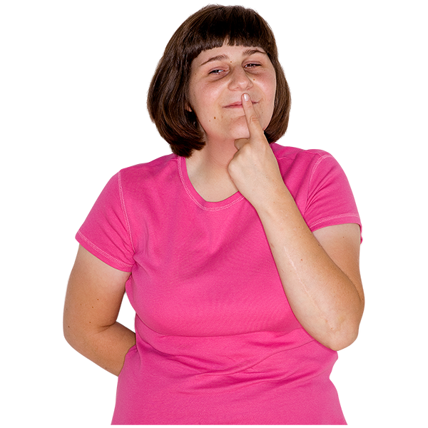
It is important to teach your child that changing their pad is private.
Changing a pad involves their private body parts and should only happen in a private place.
You can find more information on teaching your child about private and public here private and public behaviours
Periods are a normal part of life, but some people can feel embarrassed talking about it in public.
Help your child find a few trusted people they can talk to about their period in private.

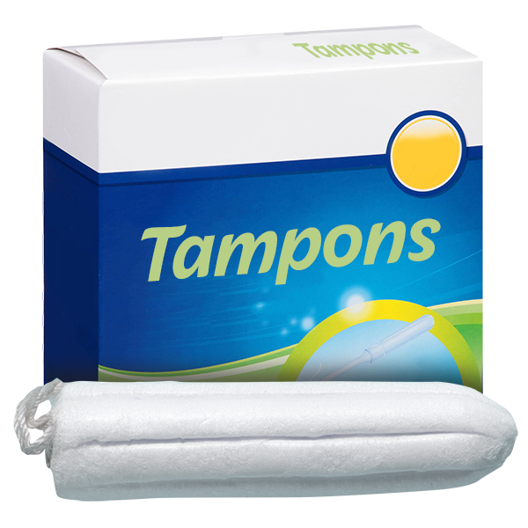
It can also be good to talk to other support people who might help your child change their pad. Help them make a plan that helps your child to change their pad safely and keeps their privacy.
What if my child does not like using pads?
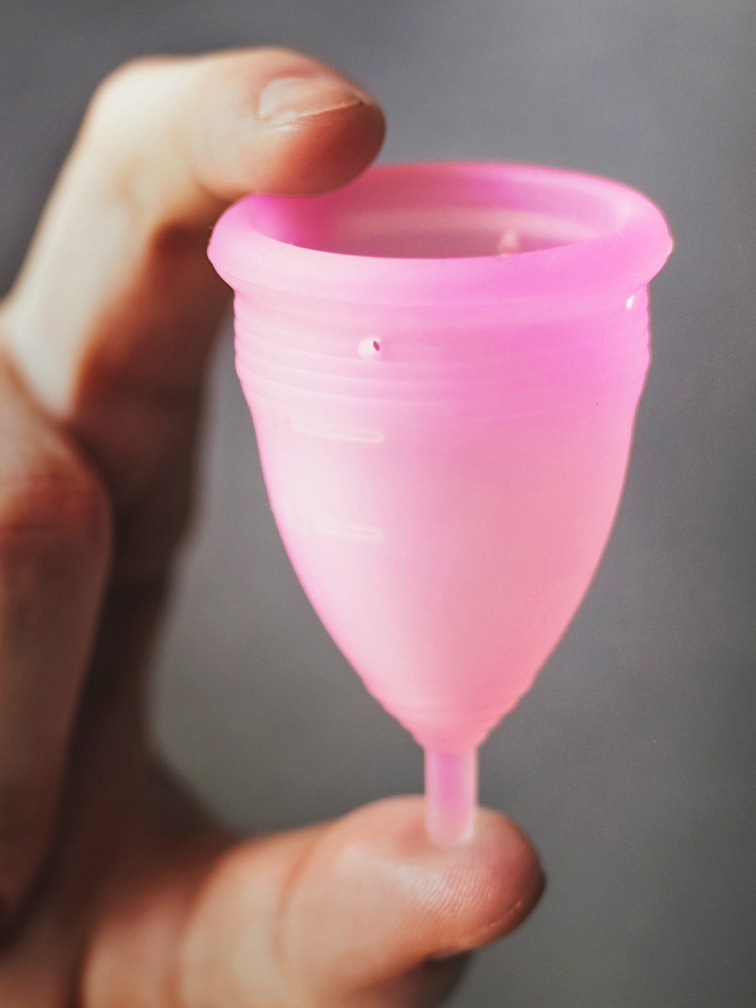
It is OK if your child does not like using a pad. There are lots of other period products your child can use. They might like to try using period underwear or tampons.
To find out more about the different period products available go to Period Product Options

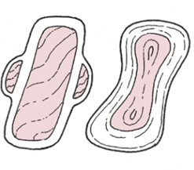
Resources for you to use
All About Sex: Periods
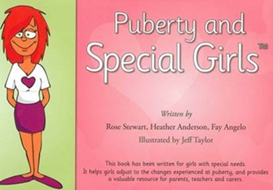
https://www.fpnsw.org.au/sites/default/files/assets/factsheet_07_periods.pdf

Puberty and Special Girls Business

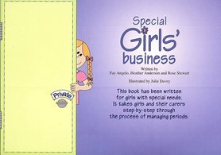
Special Girls Business

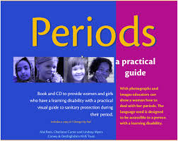
Periods: a practical guide

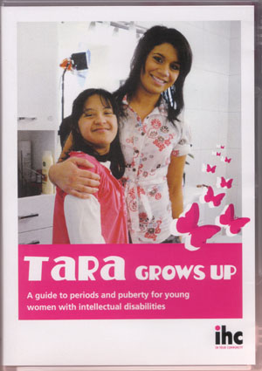
Tara Grows Up (DVD)


What to read next:
Using a tampon
What is a normal period
For more information go to the Planet Puberty website
www.planetpuberty.org.au

