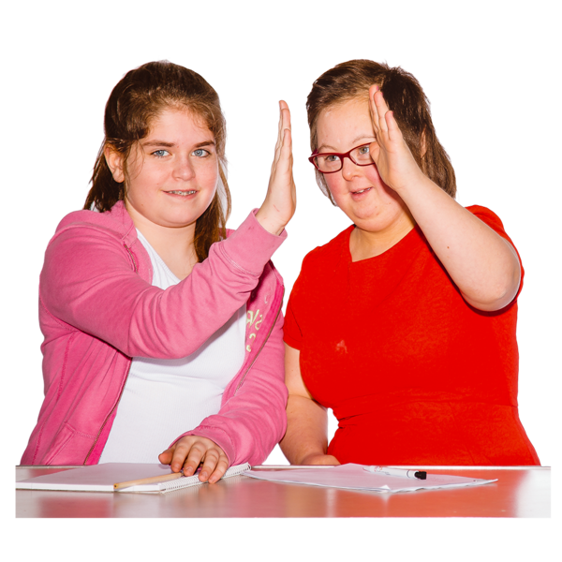Cleaning your vulva and vagina

Teaching your child to clean their private body parts is important.

It helps them to:

* keep their private body parts healthy
* be more independent
* learn about consent

What is on this page?

This page is about how you can teach your child about cleaning their vulva.

It has information on:

* girl’s private body parts
* discharge
* how to clean the vulva
* teaching your child to clean their vulva

Girl’s private body parts

There are different private body parts that your child will need to learn about.

* 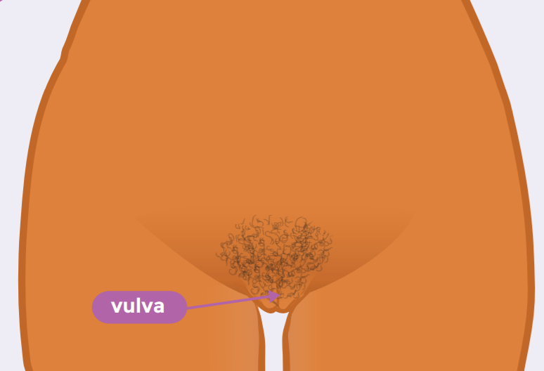**The vulva:**

is the part between the tops of a woman’s legs.

The vulva is made up of two large and two small lips of skin called the labia.

Vulvas come in different colours, shapes and sizes.

* 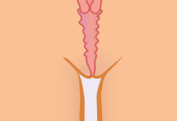**The vagina:**

opens at the vulva.

Most of the vagina is inside the body.

Period blood, discharge and babies come out of the vagina.

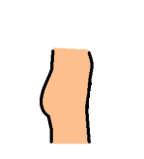

* **The bottom:**

is your backside; you sit on your bottom.

Your bottom is where your poo comes out of.

* 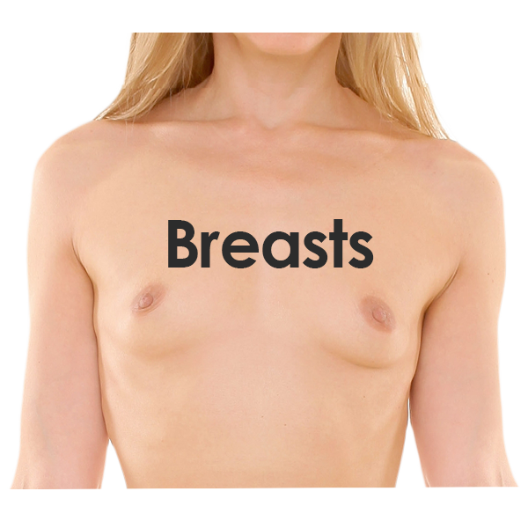**Breasts:**

grow on your chest.

They can grow as you go through puberty.

They have nipples and are used to feed babies.

It is important your child keeps their private body parts clean.

Discharge

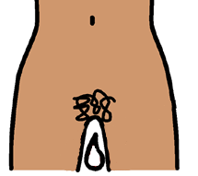Once puberty has started, the vagina starts to make a clear or white coloured liquid.

The liquid can be thick and blobby or it can be stringy and wet.

This is called discharge.

Discharge helps to keep the vagina clean.

Your child can get discharge on their underwear.

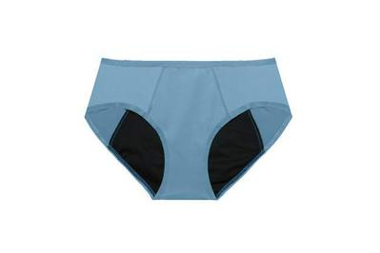It can make the underwear feel damp.

Wearing panty-liners or period underwear can soak up some of the discharge.

This can make it feel more comfortable.

Discharge can look different from day to day.

This is OK.

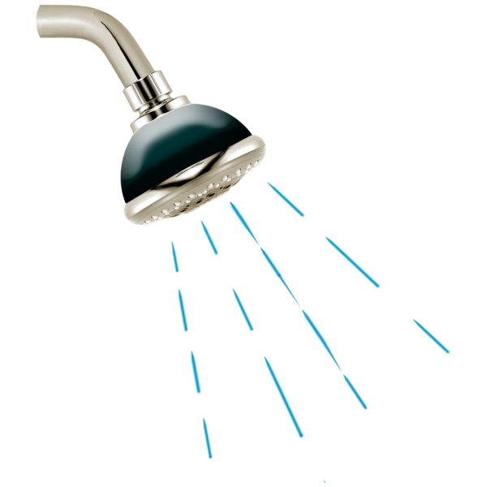If the discharge has a strong smell or looks a bit green or yellow, you should talk to a doctor.

You do not need to wash inside the vagina.

The vagina keeps itself clean.

Flushing the vagina with soap or water can make it unhealthy.

How to clean the vulva

When girls start puberty they can get a white paste in the skin folds of the vulva.

This is smegma. 

It is normal.

It is important to wash the vulva most days to clean away the smegma.

This will stop the vulva getting sore and smelly.

These steps will tell you how to clean the vulva.

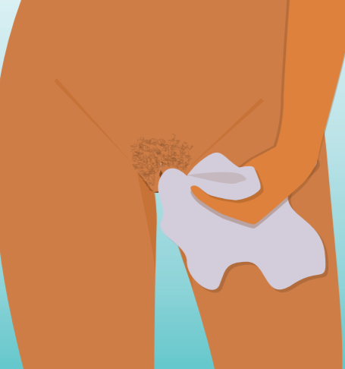Gently wash the vulva with warm water

Gently use a hand or wash cloth to clean away any smegma, sweat or sticky stuff

If you want, you can use an unscented or natural soap to clean the vulva

Be careful not to use too much soap

It can make the skin dry and sore

Teaching your child to clean their vulva

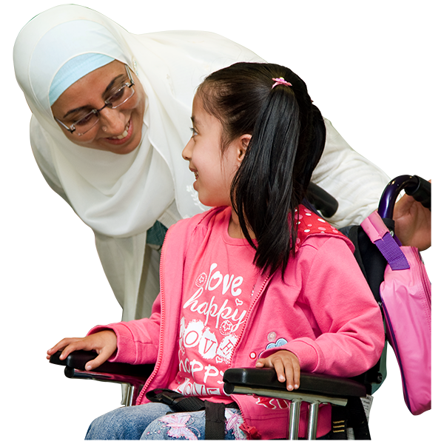Some children can find it hard to clean their vulva by themselves.

They might need some help.

This is OK.

Ask them to clean their vulva as best they can.

Then ask them if it is OK for you to help them finish washing the area.

You can say things like:

* can I help you wash your vulva?
* I am going to gently wash your vulva with the wash cloth
* is that ok?

This tells your child that taking care of their body is important and that they can say stop at any time.

Resources for you to use

Cleaning your vulva social storyPlanet Puberty

<https://www.planetpuberty.org.au/wp-content/uploads/2021/03/Cleaning-your-vulva-F.pdf>



The female reproductive system

Planet Puberty

<https://www.planetpuberty.org.au/wp-content/uploads/2021/03/The-female-reproductive-system-F.pdf>

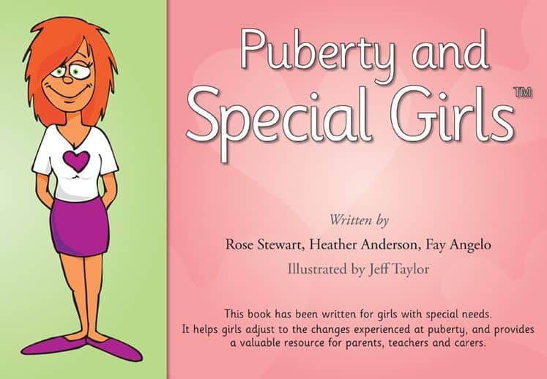Puberty and Special Girls Businessby Heather Anderson, Fay Angelo and Rose Stewart

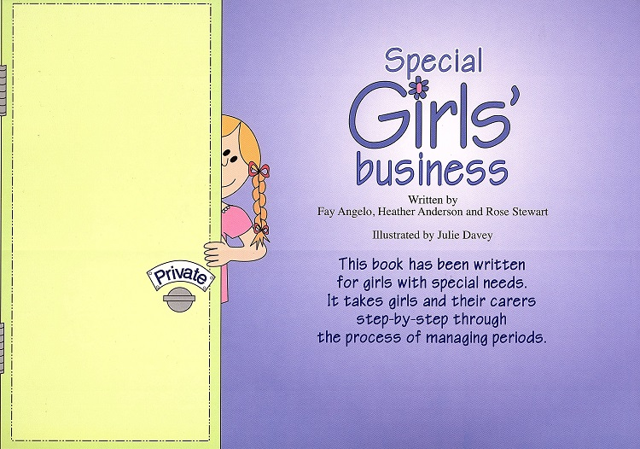Special Girls Businessby Fay Angelo, Heather Pritchard and Rose Stewart

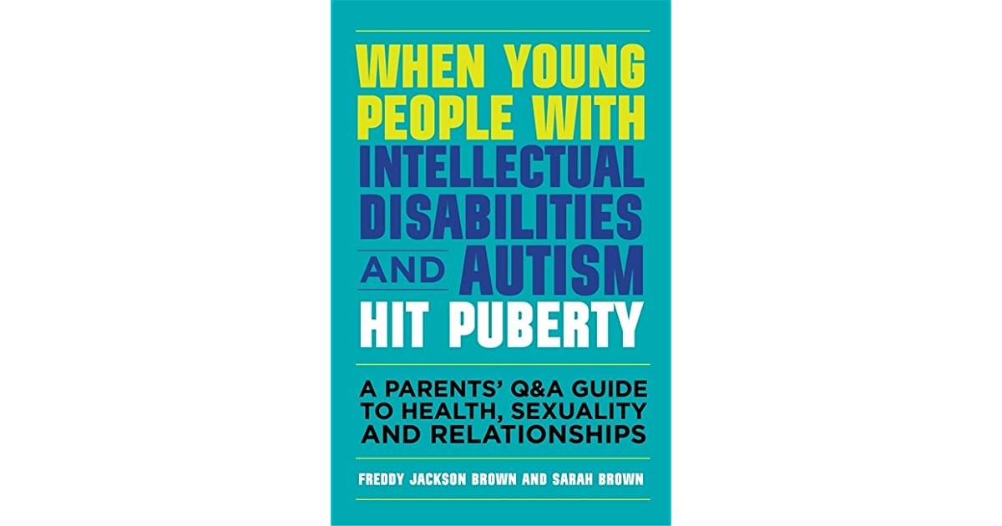

When young people with intellectual disabilities and autism hit pubertyby Freddy Jackson Brown and Sarah Brown

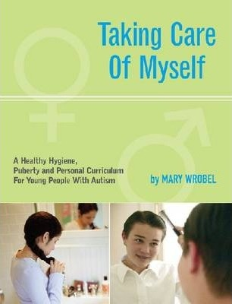

Taking care of myself by Mary Wrobel

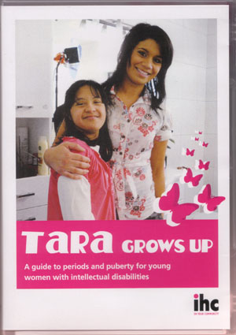

Tara Grows Up (DVD)

by IHC

What to read next:

* [Keeping your body hygienic](https://www.planetpuberty.org.au/the-body/hygiene/keeping-your-body-hygienic/)
* [Differences between girls and boys bodies](https://www.planetpuberty.org.au/the-body/body-changes/teaching-about-differences-between-girls-and-boys-bodies/)
* [Body changes](https://www.planetpuberty.org.au/the-body/body-changes/teaching-about-differences-between-girls-and-boys-bodies/)

**For more information go to the Planet Puberty website**

[Planetpuberty.org.au](https://www.planetpuberty.org.au/the-body/body-changes/teaching-about-differences-between-girls-and-boys-bodies/)