Cleaning Your Penis

Teaching your child to clean their private body parts is important. It helps them to:

* keep their private body parts healthy
* be more independent
* learn about consent

What is on this page?

This is a page about how you can teach your child about cleaning their penis.

It has information on:

* boy’s private body parts
* the foreskin
* cleaning an uncircumcised penis
* cleaning a circumcised penis
* how to teach your child to clean their penis

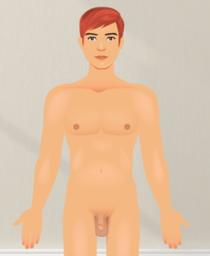Boy’s private body parts

A boy’s private body parts are his:

* penis
* testicles
* scrotum
* bottom

It is important your child keeps their private body parts clean.

They can clean their bottom and testicles with warm water and gentle soap.

If your child has a foreskin on their penis they will need to clean this too.

The foreskin

All boys are born with a foreskin. A foreskin is a roll of skin that covers the tip of the penis.

As children grow up their foreskin gets looser. It can be pulled back to show the tip of the penis. Most boys can pull back their foreskin when they start puberty.

Be gentle when pulling the foreskin back.   
If it is pulled too hard it can hurt.

You should talk to a doctor if:

* your child’s foreskin is sore
* your child has started puberty and cannot pull their foreskin back

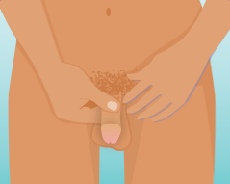Some boys have their foreskin removed by an operation. This is called circumcision. People get their children circumcised for lots of different reasons.

It is OK to have a circumcised or   
un-circumcised penis.

Cleaning an uncircumcised penis

When boys start puberty they can get white paste under their foreskin. This is called smegma. It is normal.

It is important to wash under your child’s foreskin most days to clean away the smegma.

To clean your child’s penis.

1. Clean the outside of the penis with warm water.
2. Gently wipe the penis with a hand or a wash cloth to clean away any dirt or sweat.
3. 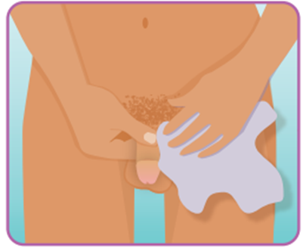Hold the foreskin between a thumb and finger. Gently slide it back to show the tip of the penis
4. Clean the tip of the penis with warm water.
5. Use a wash cloth to gently wipe any smegma or sticky stuff.

You can also use a gentle or natural soap to clean the penis. Do not use too much soap. It can make the skin on the penis dry and sore.

Cleaning a circumcised penis

To clean a circumcised penis.

1. Clean the outside of the penis with warm water.
2. Gently wipe the penis with a hand or a wash cloth to clean away any dirt or sweat.
3. Clean the tip of the penis with warm water.
4. Use a wash cloth to gently remove any smegma or sticky stuff.

Teaching your child to clean their penis

There are different ways you can help your child learn how to clean their penis.

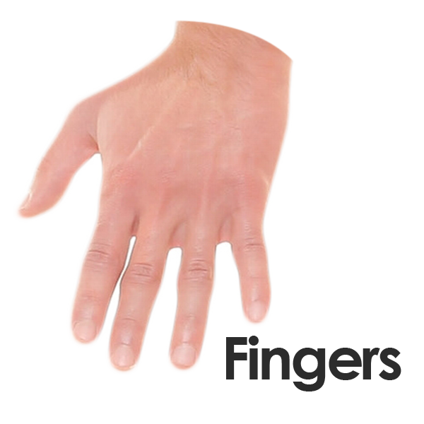

Practice cleaning on their finger

Help your child to clean their finger gently with a washcloth and warm water.

This will help them learn how to be gentle when cleaning their penis and how to wipe their penis properly.

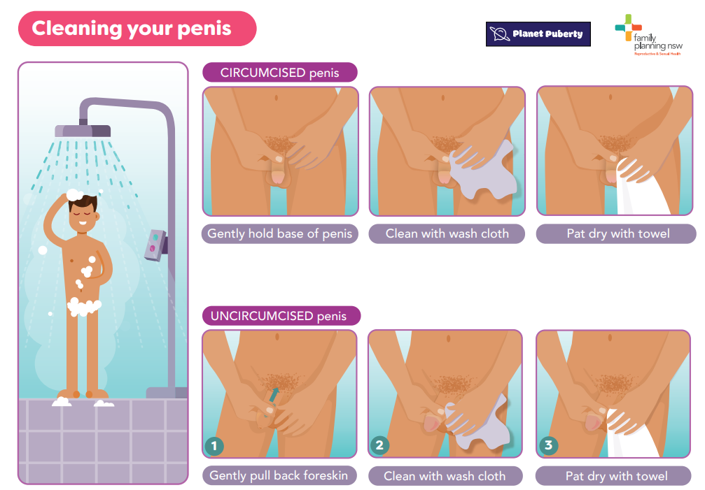Use pictures

Use pictures to help your child remember to wash their penis. Stick the pictures to the bathroom wall or shower to remind your child what they must do. Some of the pictures you might use are:

* washing the hair
* washing the face
* washing the chest
* washing the underarms
* washing the back
* washing the penis and bottom
* washing the legs
* washing the feet

Resources for you to use

Penis care article

Sex Ed Rescue

<https://sexedrescue.com/penis-care/>

Cleaning your penis visual schedule

Planet Puberty

<https://www.planetpuberty.org.au/wp-content/uploads/2021/03/Cleaning-you-penis-V4.pdf>

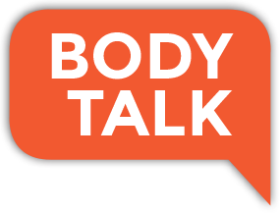Bodytalk

<https://www.planetpuberty.org.au/wp-content/uploads/2021/03/Cleaning-you-penis-V4.pdf>

What to read next?

* [Keeping your body hygienic](https://www.planetpuberty.org.au/the-body/hygiene/keeping-your-body-hygienic/)
* [Differences between girls and boys bodies](https://www.planetpuberty.org.au/the-body/body-changes/teaching-about-differences-between-girls-and-boys-bodies/)
* [Body changes](https://www.planetpuberty.org.au/the-body/body-changes/teaching-about-differences-between-girls-and-boys-bodies/)

For more information go to the Planet Puberty website

[www.planetpuberty.org.au](http://www.planetpuberty.org.au)