LGBTIQ

Identity is about learning who you are as a person.
There are lots of different things that makes up a person’s identity.
Gender identity is about whether someone feels like a man, a woman, or maybe something else.
Sexual identity is about who someone is attracted to.
Sometimes people use the term ‘LGBTIQ’ when talking about different identities.

LGBTIQ stands for:
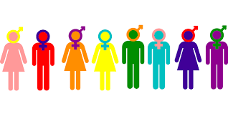
L: Lesbian
G: Gay
B: Bisexual
T: Transgender
I: Intersex
Q: Queer
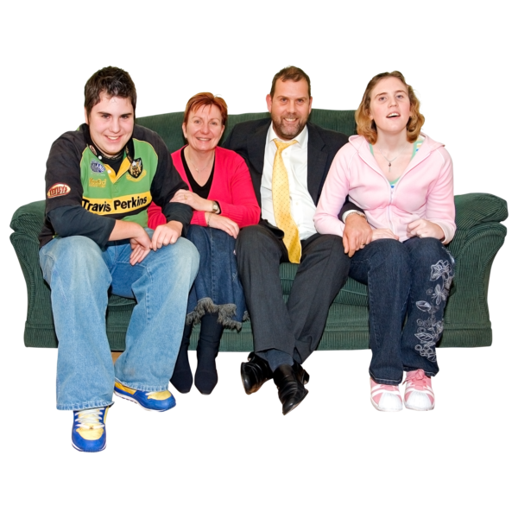
LGBTIQ people are a part of every community.
They are loved members of many families.
It is important to teach your child about the LGBTIQ community so they can:
- understand how to treat LGBTIQ people with respect
- understand their own sexual or gender identity

What is on this page?
This page has information on how to support your child to learn about the LGBTIQ community.

It has easy read information on:
- what LGBTIQ means
- why it is important to learn about the LGBTIQ community
- what to do if your child is LGBTIQ
- things you can do to teach your child about the LGBTIQ community

What does LGBTIQ mean?
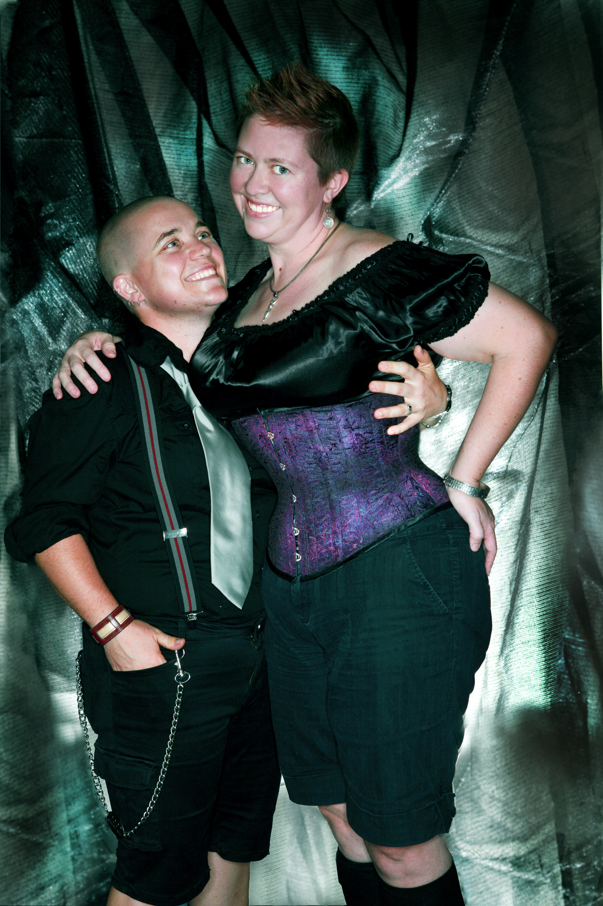
Some women are attracted to other women.
They might call themselves lesbian.
Some men are attracted to other men.
They might call themselves gay.
Some people are attracted to both men and women.
They might call themselves bisexual.

Some people feel they are different from the gender they were at birth.
Some people who look like boys when they were born grow up feeling like they are a girl.
Some people who look like girls when they were born grow up feeling like they are a boy.
These people might call themselves transgender.
Intersex people are born with bodies that are different to what people usually think about men’s or women’s bodies.
Intersex people might have private body parts that look different to what men’s or women’s private body parts usually look like.
Or they might have private body parts that work differently to how men’s or women’s private body parts usually work.
Every intersex body is different.
Some people might call themselves queer if the other terms do not fit their gender or sexual identity.
Other people might not like the term queer. That is OK.
It is up to each person to decide what their identity is.
Why it is important to learn about the LGBTIQ community?
All people have the right to be respected.
This includes LGBTIQ people.

Showing respect for the LGBTIQ community teaches your child to respect all people for who they are.
Talking about respecting LGBTIQ people will not change your child’s sexual or gender identity.
But it can help your child feel safe if they are not sure about their gender or sexual identity.

What if my child is LGBTIQ?

It is OK if:
- your child is unsure about their gender or sexual identity
- your child tells you they are LGBTIQ
You might be a bit worried but do not panic!

Remind your child that you will always love them and support them.
Ask your child if they want to talk to you about what they are feeling.
If they do not want to talk or are not ready to talk, that’s OK too.
You can help your child by creating a safe space for them to develop their gender and sexual identity.
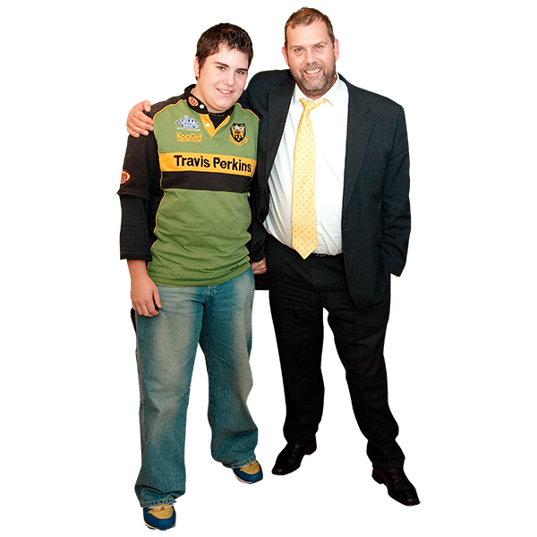
You can create a safe space by:
- asking your child what they need to feel safe at home
- asking them what they need to feel safe at school
- making sure that friends and family do not use mean words about LGBTIQ people
- letting them wear the clothes they want to wear

Some support services that may be helpful are:
- QLife https://qlife.org.au/
- Kids Helpline https://kidshelpline.com.au/
Sometimes children who are LGBTIQ get bullied.
If you are worried about your child being bullied, go to Bullying for more information.
Things you can do to teach your child about the LGBTIQ community
Use respectful language

Using respectful language about LGBTIQ people is a good way to help everyone feel safe.
Show your child how you use respectful language when talking to other people.
This will show your child how they can talk with others in a respectful way.
It also shows your child that you are OK with their gender and sexual identity.

Use teachable moments:
A teachable moment is a time in everyday life to learn or practice a new thing.
Here some examples of ways you can use teachable moments to start talking to your child about the LGBTIQ community:
- ‘Your friend at school has two mums.
- Do you know what that means?’
- ‘That character on TV just came out as gay.
Do you think that would have been hard for them?’


Resources for you to use
All About Sex - Lesbian, Gay, Bisexual, Transgender factsheets
Family Planning NSW
https://www.fpnsw.org.au/factsheets/individuals/disability/all-about-sex

Outing Disability
Family Planning NSW and Belinda Mason
www.outingdisability.com.au

What should I tach my middle schooler about identity?
Planned Parenthood
https://www.plannedparenthood.org/learn/parents/middle-school/what-should-i-teach-my-middle-schooler-about-identity

What should I tach my high schooler about identity?
Planned Parenthood
https://www.plannedparenthood.org/learn/parents/high-school/what-should-i-teach-my-high-school-aged-teen-about-identity

Caring for kids
https://www.caringforkids.cps.ca/handouts/gender-identity

Twenty10
https://www.twenty10.org.au/

Qlife
https://qlife.org.au/

LGBTIQ ultimate dictionary
Kidshelpline
https://kidshelpline.com.au/teens/issues/lgbtiq-ultimate-dictionary

Inclusive language guide
LGBTI Health
https://www.lgbtihealth.org.au/inclusive_language_guide

What to read next?
- Supporting gender and sexual identity
- Creating a positive self-image
- Supported Decision Making
For more information go to the Planet Puberty website
www.planetpuberty.org.au

