Types of Relationships
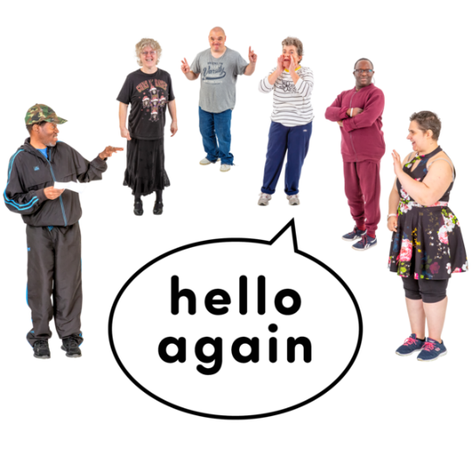
There are many things your child needs to learn about relationships.
First they need to learn about the different types of relationships.
Learning about the different types of relationships will help your child to:
- understand how they should act with different people
- understand the types of touch that are OK in relationships
- have healthy relationships

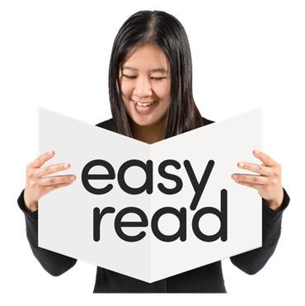
What is on this page?
This page is about how you can teach your child about different types of relationships.
It has information about:
- the different types of relationships
- how you can talk to your child about different types of relationships
- things you can try when teaching your child about the different types of relationships
Types of relationships
There are 6 types of relationships.
- Strangers: These are people you do not know.
For example, people on the bus or people walking down the street

- Acquaintances: These are people you only know a little bit.
For example, the person who works at the local supermarket or your neighbour from down the road
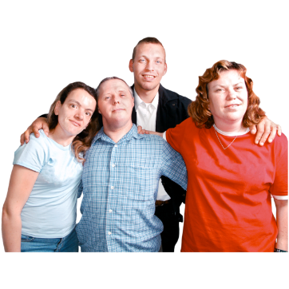
- Professional helpers: These are people whose job it is to help you.
For example, doctors, teachers and support workers
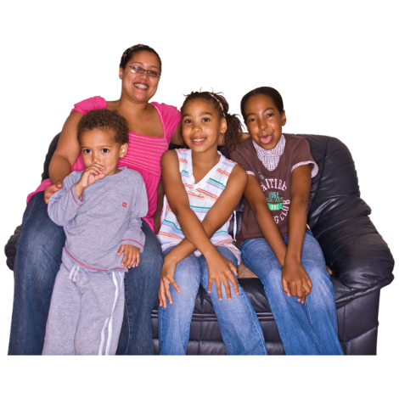
- Friends: These are people you like and know well.
For example, friends from school or sport
- Family: These are people like mum and dad, brothers and sisters, grandmothers and grandfathers
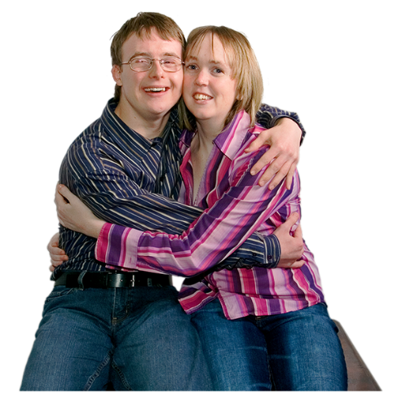
- Intimate partners: For example, boyfriends and girlfriends, husbands and wives
All relationships are different.
This is OK.
Some people have many friends.
Some people have a few.
Some people have big families.
Some people have small families.
It is important to teach your child that different people have different relationships.

Talking about types of relationships
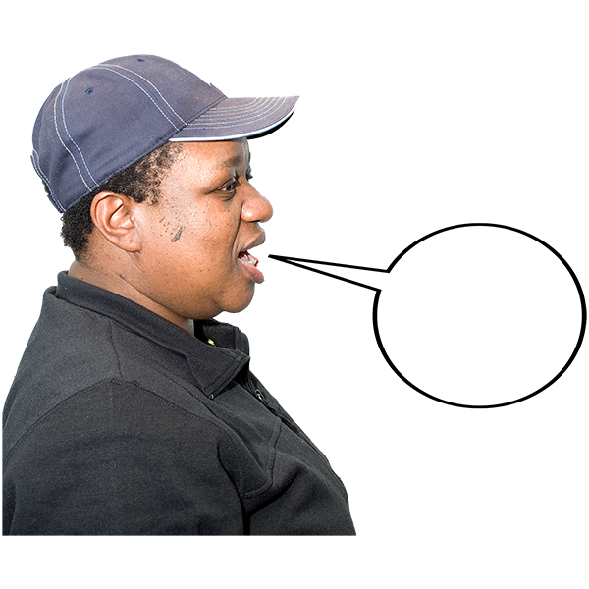
Here are some things you can say to start talking to your child about different relationships:
- “You seem to get along well with the new student in your class.
- What type of relationship do you think that is?
- “Do you see those two people over there?
Do you think they know each other?”
- “Those characters seem to know each other well.
What type of relationship do you think they have with each other?”

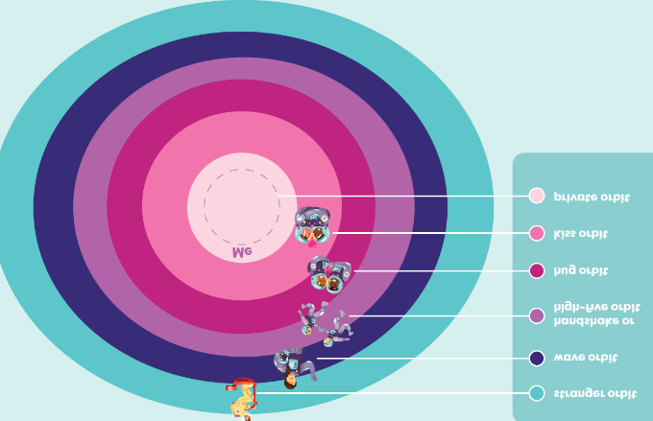
Things for you to try
Who is in my orbit worksheet
Use the ‘Who is in my orbit’ worksheet to help your child learn about the different types of relationships. You can find the worksheet here.
Ask your child to put the people they know if one of the circles.
Ask them what type of touch might be OK.
Remind them that both people must say ‘yes’ to any type of touch.
Hang the finished worksheet on your child’s bedroom wall.
Use it to remind them what types of touch are OK with a person they know.

Teachable moments
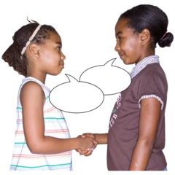
A teachable moment is when you use an event or experience to teach something.
You can use teachable moments to teach your child about relationships.
For example:
- when you introduce a new person to your child, say the person’s name and their relationship to you
- when you see somebody you know at the shops, ask your child to tell you who they are.
You can then ask them what type of relationship they have with them

Resources for you to use
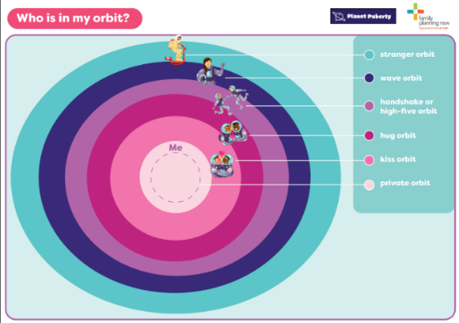
Who is in my orbit worksheet
Planet Puberty
https://www.planetpuberty.org.au/wp-content/uploads/2021/03/Whos-in-my-Orbit-F.pdf

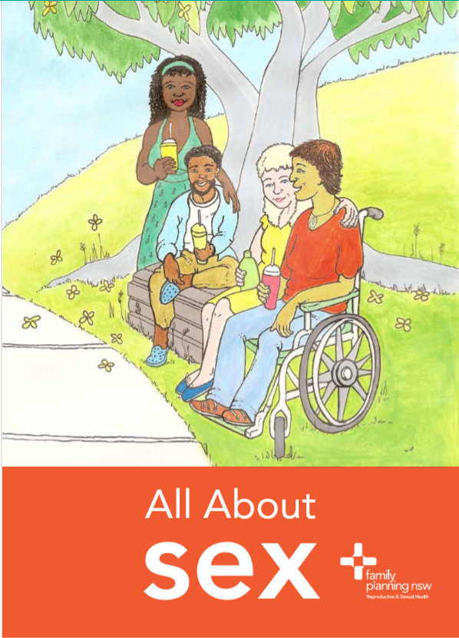
All About Sex factsheet - Relationships
Family Planning NSW
https://www.fpnsw.org.au/sites/default/files/assets/factsheet_09_relationships.pdf

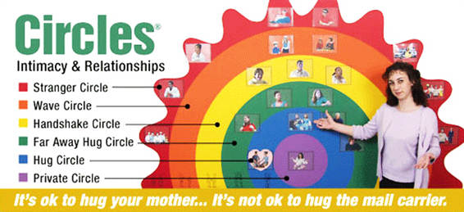
Circles – Intimacy and Relationships program
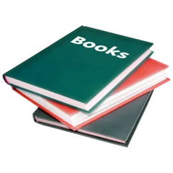
http://bciu22.angelfire.com/Circles.html#:~:text=CIRCLES%C2%AE:%20Intimacy%20&%20Relationships%20Education

Relationship Skills: A Photo Resource
Liz Dore – relationships and private stuff
https://www.relationshipsandprivatestuff.com/


What to read next?
- Things people do in relationships
- Consent in relationships
- Feelings in relationships
For more information go to the Planet Puberty website
Planetpuberty.org.au

